AI Assisted Coding
Assignment-5.1&6

Name: k.Sri priya
Batch: 31
HT NO: 2303A5334

Task 1:
Employee Data

Code:
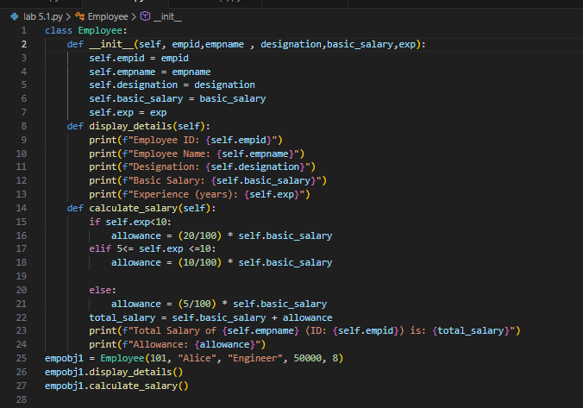
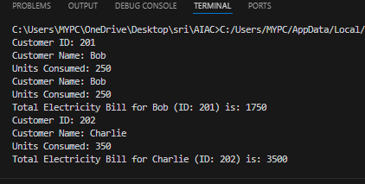

Task 2:
Electricity Bill Calculation

Code:
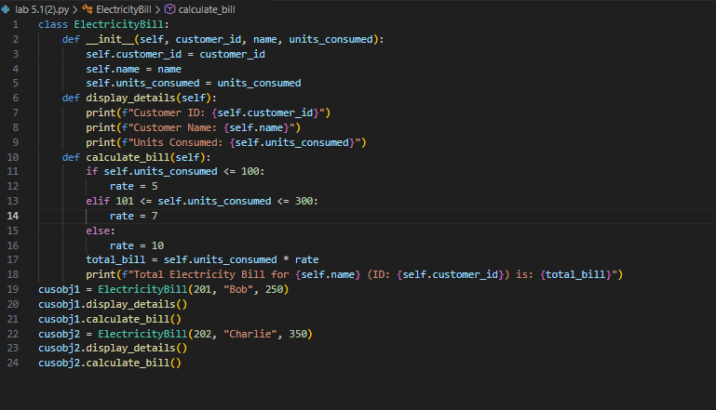

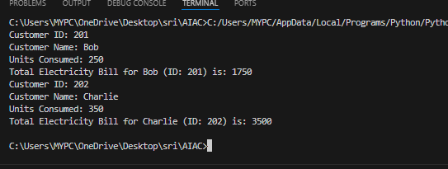

Task 3:
Product Discount Calculation

Code:
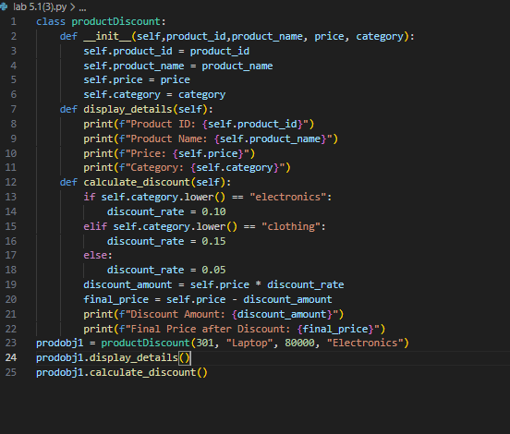

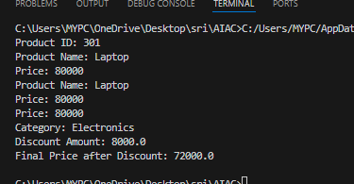

Task 4:
Book Late Fee Calculation

Code:
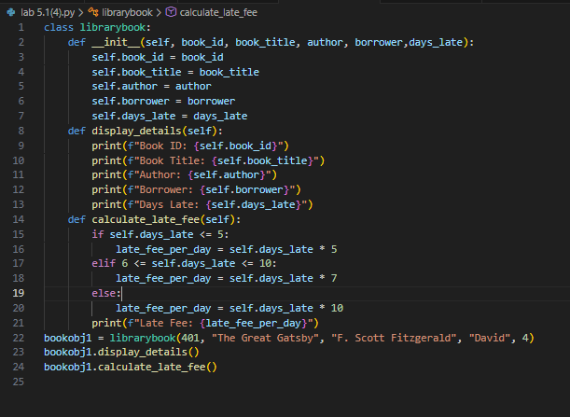
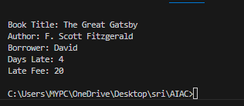

Task 5:
Student Performance Report

Code:
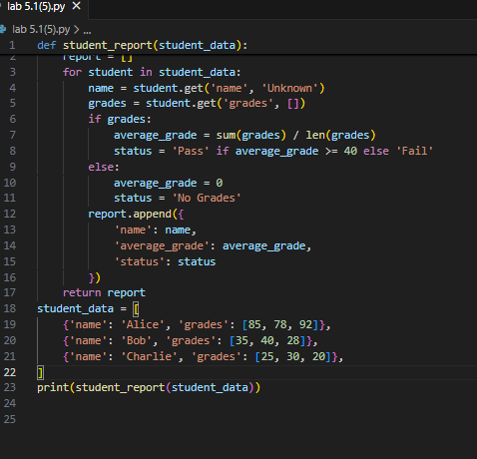

Task 6:
Taxi Fare Calculation

Code:
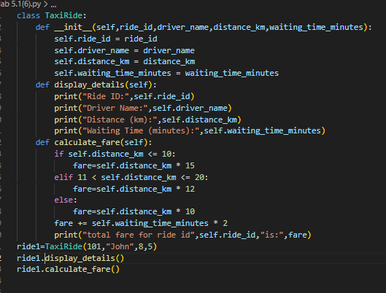
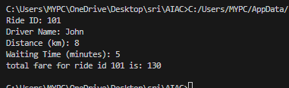

Task 7:
Statistics Subject Performance :

Code:
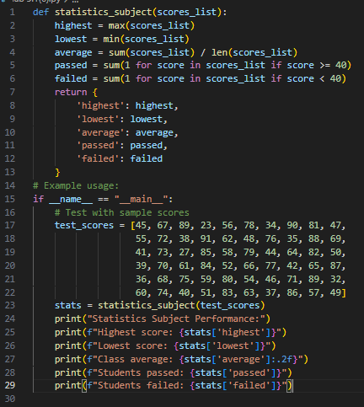
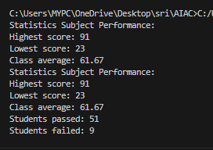

Lab 5: Ethical Foundations – Responsible AI Coding Practices

8 .Transparency in Algorithm Optimization

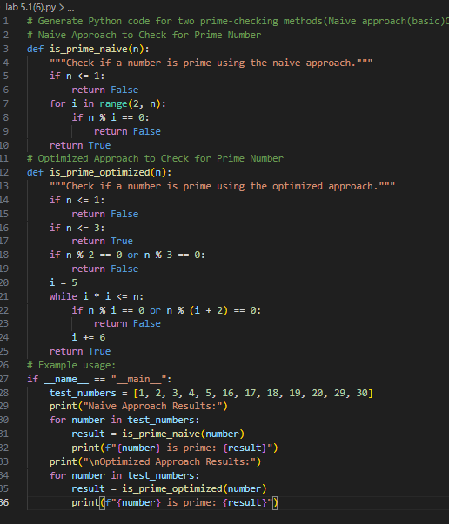

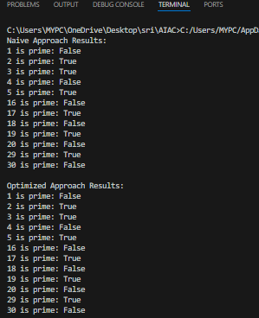

Naive Method
Checks the number by dividing it with all numbers before it.Needs many checks for large numbers and IT takes more time.
Time Complexity: O(n)

Optimized Method

Checks the number only up to its square root .Skips unnecessary divisions and It takes less time.
Time Complexity: O(√n)

- Transparency in Recursive Algorithms

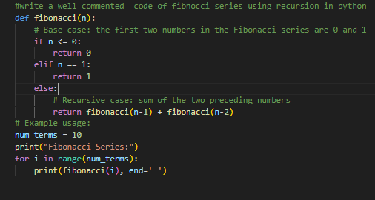

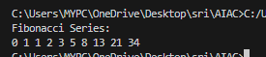

- Transparency in Error Handling

